kčkčjk

ćm
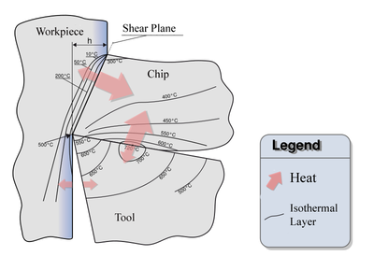
Slika: Principle of combined through the spindle delivery of CO₂ and MQL

Slika: Combined delivery of CO₂ and MQL in drilling

REFERENCE
- L.Čerče: Napovedovanje obstojnosti rezalnih orodij z upoštevanjem njihove prostorske obrabe: doktorska disertacija, Ljubljana 2016
- J.Kopač, M.Soković; Tehnika odrezavanja. Sodobna rezalna orodja / Janez kopač, Mirko Soković. - Ljubljana : Fakulteta za strojništvo, 1993 (ISBN: 86-7217-097-0)
- J.Kopač: Odrezavanje: Teoretične osnove in tehnološki napotki / J.Kopač - Ljubljana [samozal.] J.Kopač, 2008 (ISBN 978-961-245-583-5)

PROBLEMATKA
- The processing of difficult-to-machine materials is due to their high thermo-mechanical tool loads and their high adhesion tendency possible just under low cutting speeds and using cooling lubricants.
- This results in long processing times, low productivity and high costs.
- The "cryogenic machining" in combination with minimum quantity lubrication represents an innovative approach for increasing productivity and step into direction for achieving dry and clean machining processes.

PRINCIP DELOVANJA
- Increase productivity in the milling and drilling of difficult-to-machine materials by using a combined supply of cryogenic media (CO₂ and N₂) and minimum quantity lubrication through the spindle.
- Analysis of the operating mechanisms and temperatures, as well as development of adapted process strategies and tools for combined, internal delivery of both mediums also for small solid tools.

Stanje tehnike
- Increase productivity in the milling and drilling of difficult-to-machine materials by using a combined supply of cryogenic media (CO₂ and N₂) and minimum quantity lubrication through the spindle.
Analysis of the operating mechanisms and temperatures, as well as development of adapted process strategies and tools for combined, internal delivery of both mediums also for small solid tools.

Referenca: Walter

